***C0404 Custom Event : Information Pop Up - Tax Code Change***

|  |  |  |  |  |
| --- | --- | --- | --- | --- |
| **Ver** | **Date** | **Author** | **Comments** | **Reviewed by** |
| 1 | 01/12/2020 | Linzi Evans |  | TBC |
|  |  |  |  |  |

Requirements 2

Prerequisites 2

Solution Overview 2

Solution Details 2

Security 3

Companies 3

Data Migration 3

Test Steps 3

Technical Implementation 3

Requirements

Custom event – information pop-up to prompt coordinator to attach tax exemption document. The pop up should happen when the tax code is changed on the order line.

Prerequisites

The customer must have the following tax codes available:

CH0

CH5

CH20

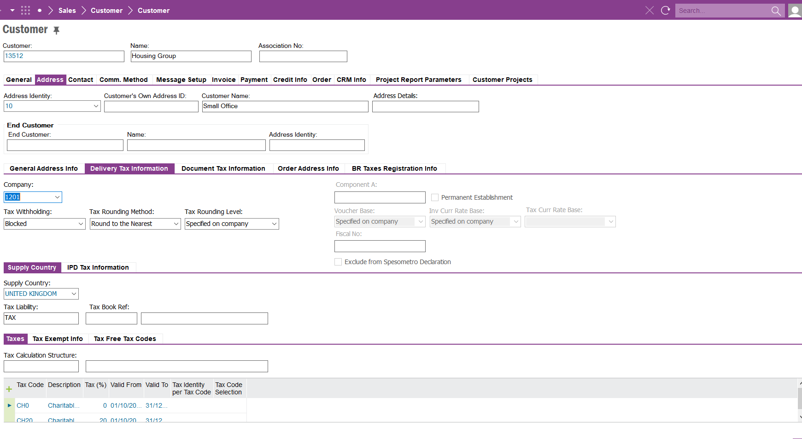

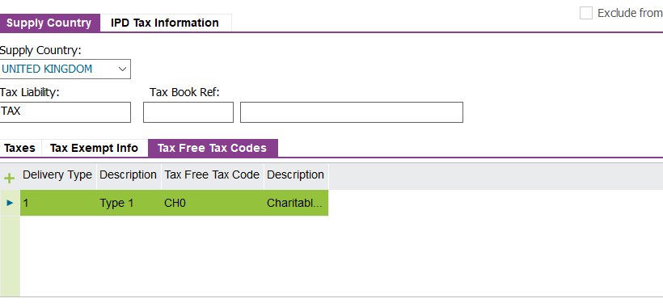

Solution Overview

When tax code is changed to CH0,CH5 or CO20 on the order line an Information Message pop up to remind user to attach Tax Exemption Document.

Solution Details

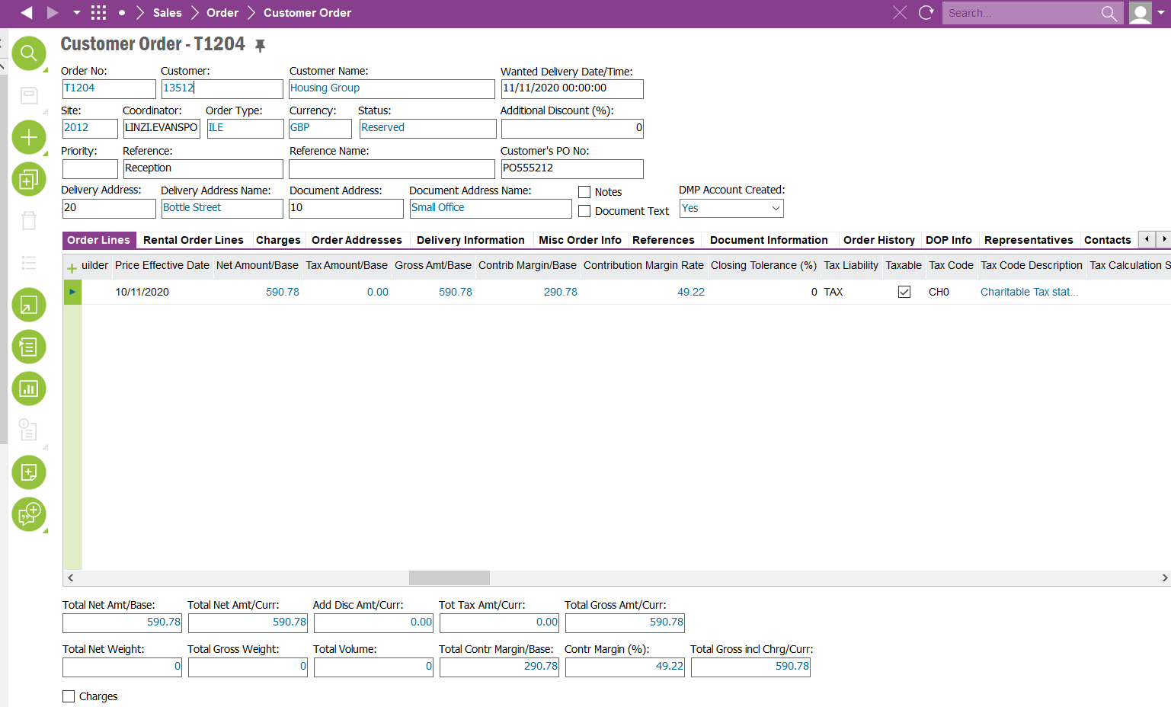

When the tax code is changed on the order line, a pop-up information message will appear to prompt user to attach required document.

Information Message to say:

**Attach Tax Exemption Document.**

<New Field/CLU Definition>

|  |  |  |  |  |  |  |
| --- | --- | --- | --- | --- | --- | --- |
| New DB Object Name | DB Object Item/Field Names | Item Description | Item Data Type | Item Syntax | Calculation Spec, if Derived | LOVs/Enums/Is Mandatory? |
|  |  |  |  |  |  |  |
|  |  |  |  |  |  |  |
|  |  |  |  |  |  |  |
|  |  |  |  |  |  |  |
|  |  |  |  |  |  |  |
|  |  |  |  |  |  |  |
|  |  |  |  |  |  |  |
|  |  |  |  |  |  |  |
|  |  |  |  |  |  |  |
|  |  |  |  |  |  |  |
|  |  |  |  |  |  |  |
|  |  |  |  |  |  |  |

Security

All users with a sales profile.

Companies

Applies to the following companies

|  |  |
| --- | --- |
| **Company** | **Required (Y/N)** |
| 1201 | Y |
|  |  |
|  |  |

Data Migration

N/A

Test Steps

<Steps that needs to be taken to test this change. Please provide expected results>

|  |  |  |
| --- | --- | --- |
| **No** | **Script\Test Steps** | **Expected Result** |
| 1 | Create Customer Order and change tax code to CH0. | Information message pop up to appear stating, ‘Attach Tax Exemption Document’ |
|  |  |  |
|  |  |  |
|  |  |  |
|  |  |  |
|  |  |  |

Technical Implementation

**Package**

EA_COM

**Permissions Granted**

IFS_ALL

**Custom Event**

Make sure the event and event action is enabled.

